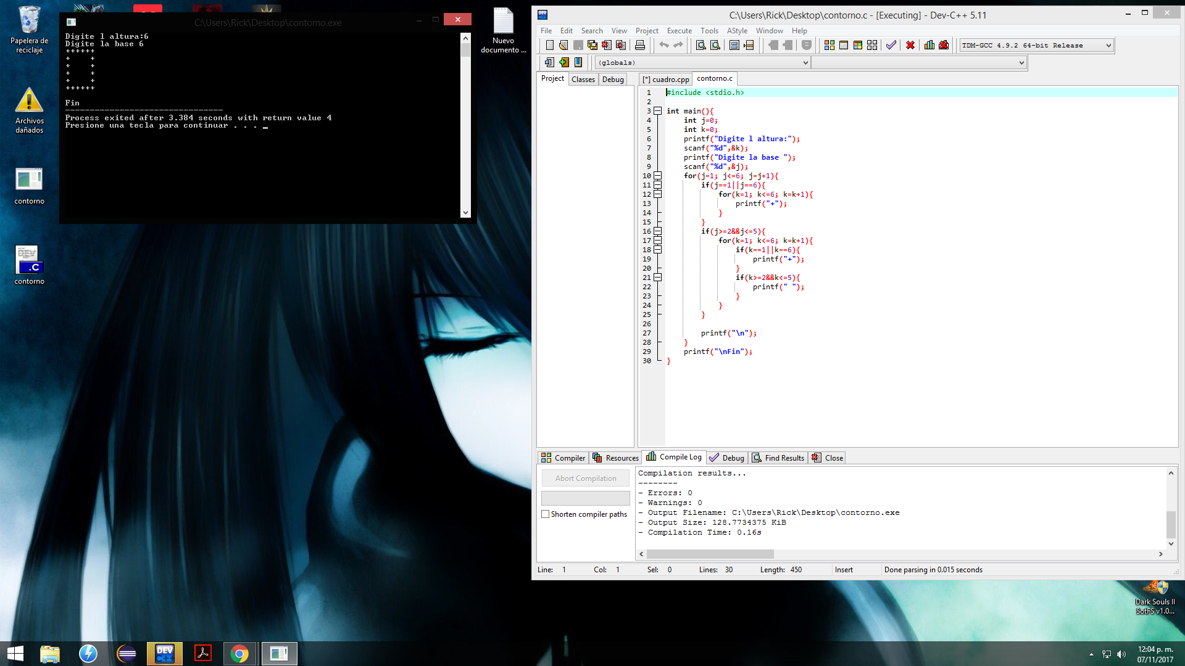

#include <stdio.h>

int main(){

int j=0;

int k=0;

printf("Digite l altura:");

scanf("%d",&k);

printf("Digite la base ");

scanf("%d",&j);

for(j=1; j<=6; j=j+1){

if(j==1||j==6){

for(k=1; k<=6; k=k+1){

printf("+");

}

}

if(j>=2&&j<=5){

for(k=1; k<=6; k=k+1){

if(k==1||k==6){

printf("+");

}

if(k>=2&&k<=5){

printf(" ");

}

}

}

printf("\n");

}

printf("\nFin");

}